**DOKUZ EYLUL UNIVERSITY**

**ENGINEERING FACULTY**

**DEPARTMENT OF COMPUTER ENGINEERING**

**JOURNEY PLANNER FOR IZMIR**

**PUBLIC TRANSPORTATION**

**by**

**2017510063 – Arif Mertaslan**

**LECTURES**

**Prof.Dr. Zerrin IŞIK**

**Res.Asst. Altuğ YİĞİT**

**Res.Asst. Ali CÜVİTOĞLU**

**Res.Asst. Feriştah DALKILIÇ**

**22 December 2019**

**İZMİR**

**PROJECT DESCRIPTION**

A journey planner (or trip planner) is a specialized electronic search engine that finds one or more journey (trip) suggestions between an origin and a destination. This system assists travelers for planning their journey.

Izmir is Turkey's the third largest city and has four existing public transport companies including ESHOT for bus transportation, Izmir Metro Inc. for metro, IZBAN Inc. for the rail system and IZDENIZ for maritime transport. All of these systems form a complete transportation network with 319 lines and 6708 stops/stations.

Dijkstra's algorithm forms the basis of modern journey planner search algorithms and provides an optimal solution to simple searches. While planning routes in such a combined network, some constraints as switching the mode of transportation frequently or unacceptable transfer counts must be considered. For instance, Figure 1 shows the result path produced by the original Dijkstra’s algorithm for a query from the source stop ‘100036-Konak.’ To the destination stop ‘40661-Evka-1’.

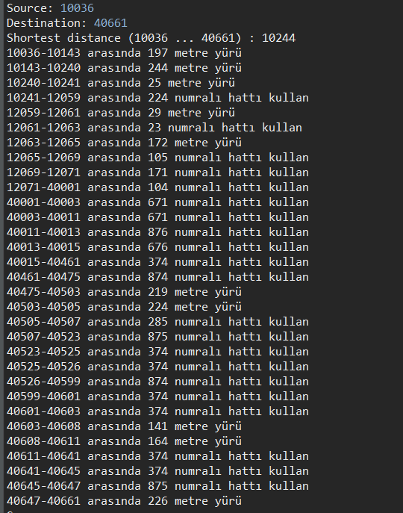

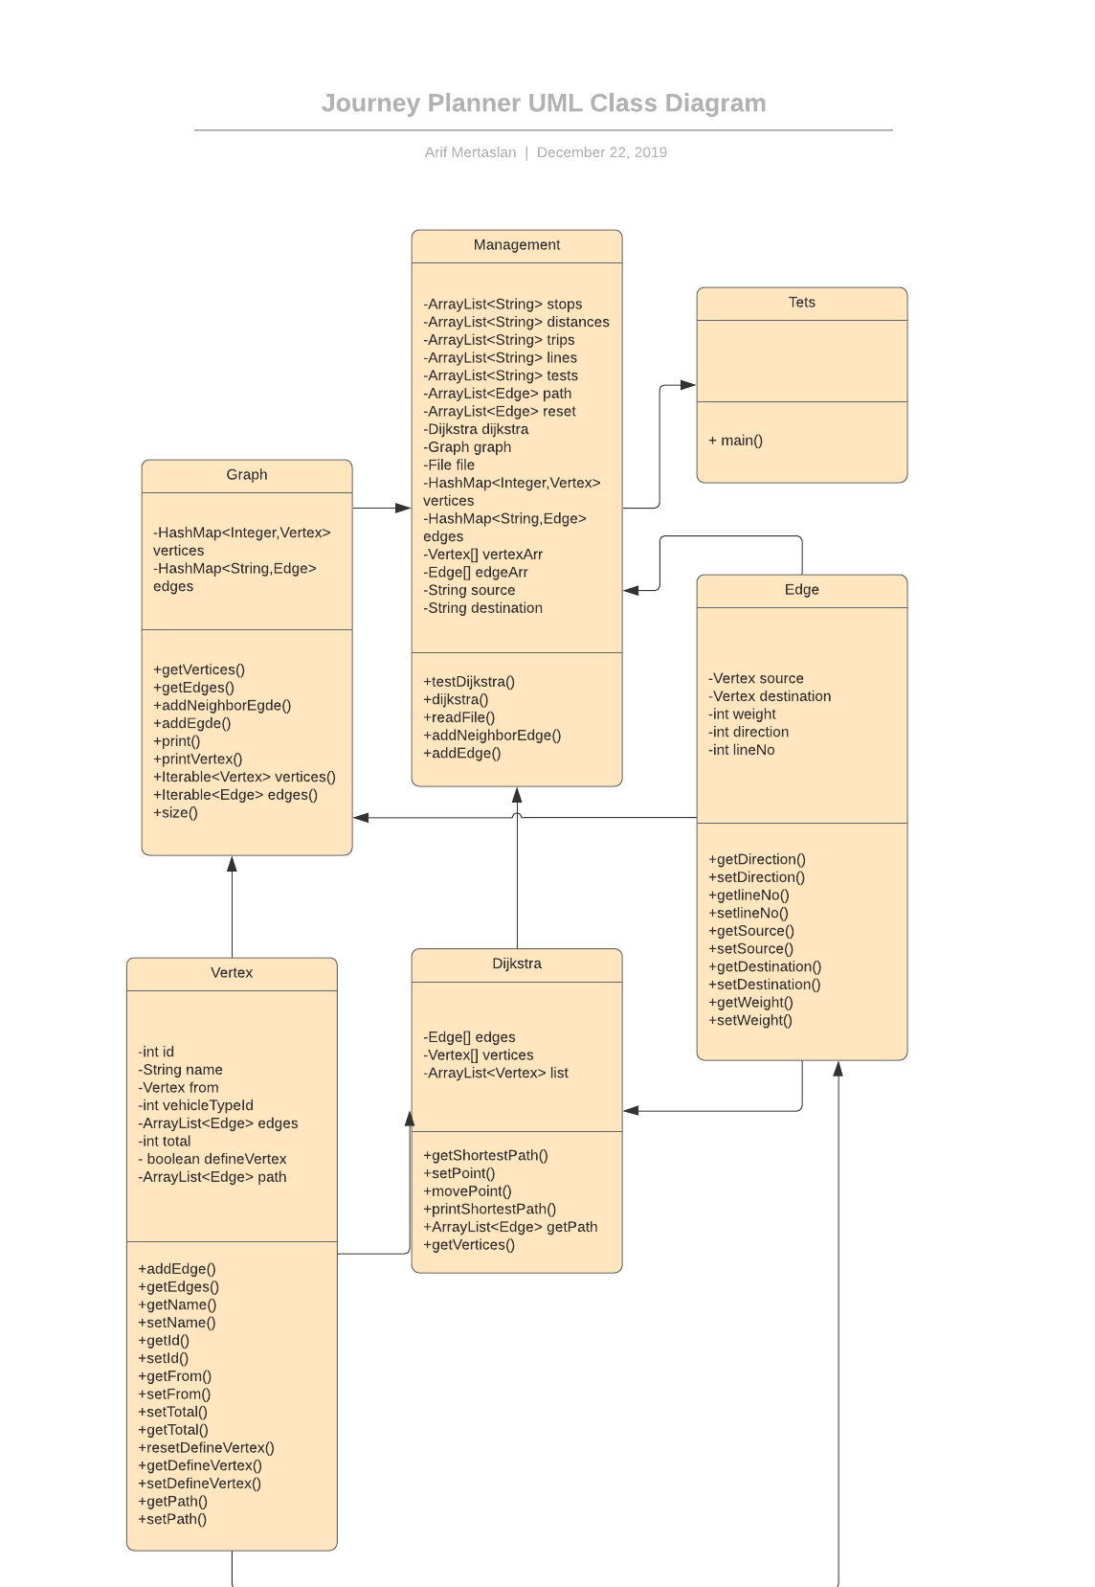

**TEST QUERIES**

Reading files and creating graph time is 35.50 seconds.

Average query time is 1.40 seconds.

Test stops file tests examples;

